# Accuracy:

* CNN

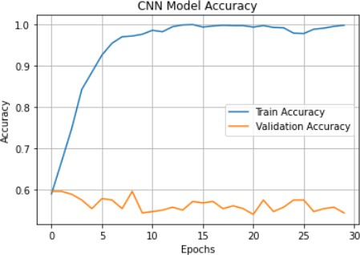

* LSTM

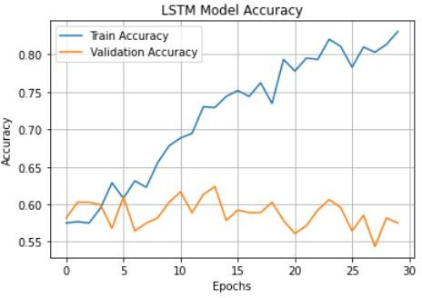

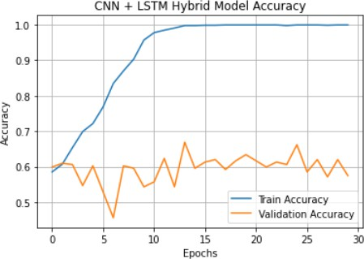

* RESNET50

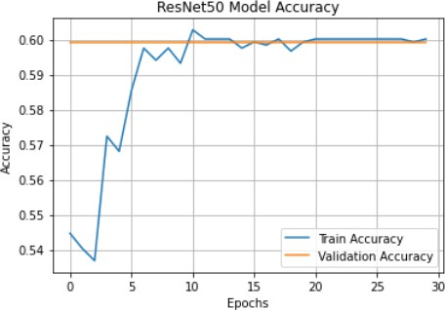

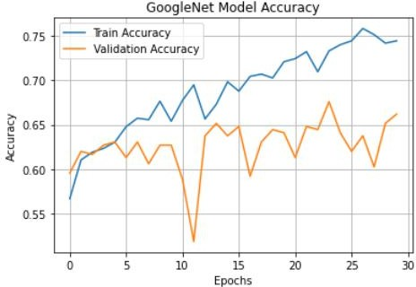

* XCEPTION

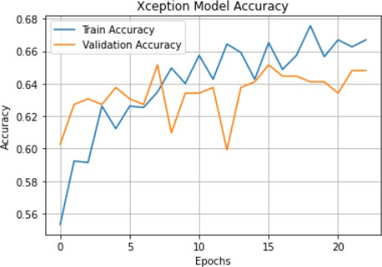

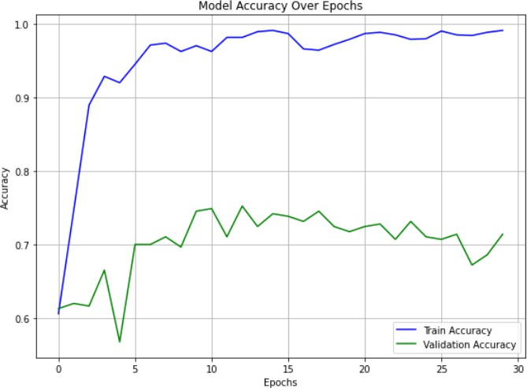

# Precision:

* CNN



* LSTM
* CNN + LSTM



* RESNET 50



* GoogleNET
* XCEPTION



* GoogleNET + XCEPTION



* CNN:



* LSTM



* CNN+LSTM



* RESNET 50



* GoogleNET



* Xception



* GoogleNET+ XCEPTION



# F1-Score

* CNN



* LSTM



* CNN + LSTM



* RESNET 50



* GoogleNET



* XCEPTION



* GoogleNET + XCEPTION



# Characteristic Curve)

* CNN

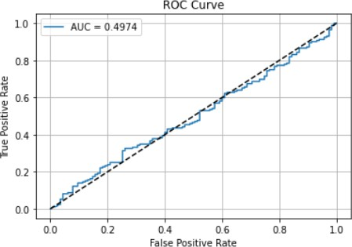

* LSTM

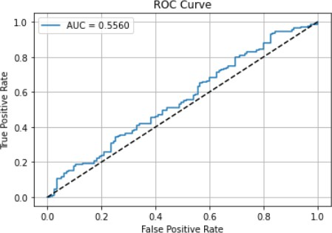

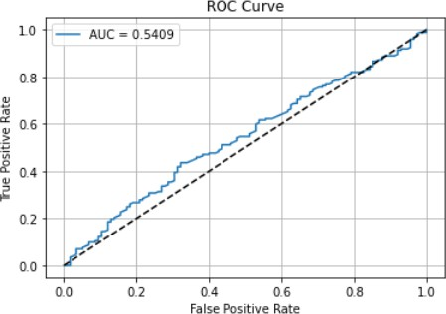

* RESNET 50

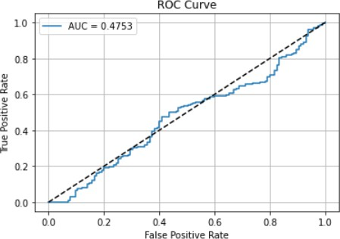

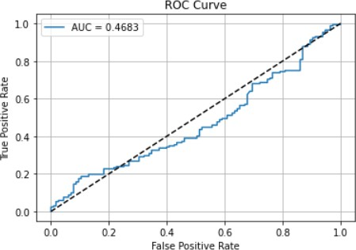

* XCEPTION

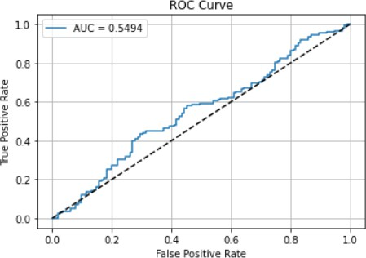

* GoogleNET + XCEPTION

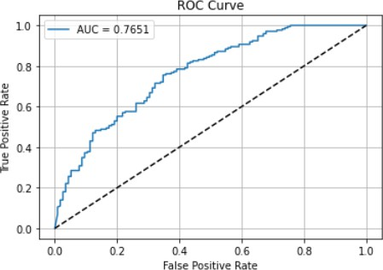

**MODEL WISE ALL DETAILS**

**CNN**

